# Exercise: Simple XAML Layout

Using a stack layout, create a simple calculator app that allows the user to enter two numbers, choose an operation (Add, subtract, divide, or multiply), and view the result.

The end result will look something like this:

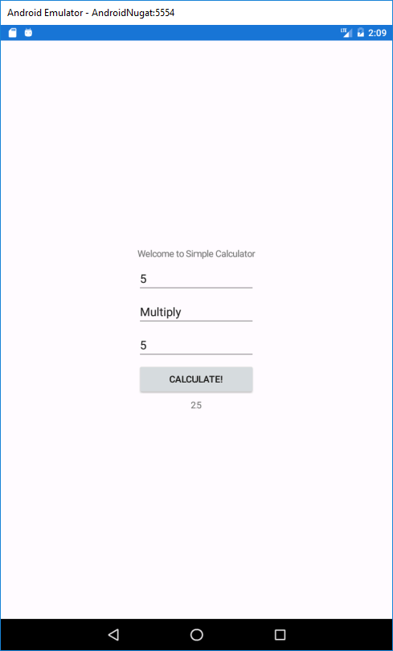

You can use an Entry control for reading input, a Label for output, a Button for initiating the calculation, and a Picker for choosing the operation.

For the picker, look at the documentation at <https://developer.xamarin.com/guides/xamarin-forms/user-interface/picker/populating-itemssource/>. You can read the selected item using the SelectedItem property and calling ToString if needed.